Useful Python Commands

Basic Functions

print()  
We have already used print(). It prints your stuff to the screen.  
Example: print("Hello, World!")

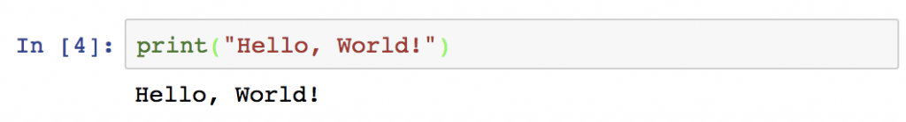

abs()  
returns the absolute value of a numeric value (e.g. integer or float). Obviously it can’t be a string. It has to be a numeric value.  
Example: abs(-4/3)

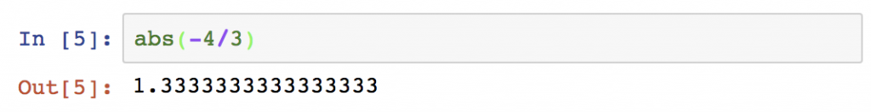

round()  
returns the rounded value of a numeric value.  
Example: round(-4/3)

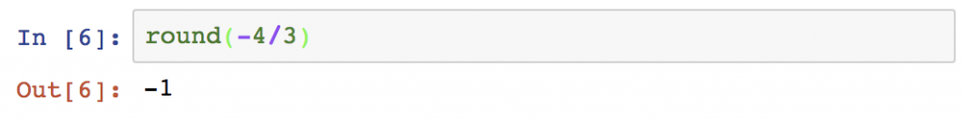

min()  
returns the smallest item of a list or of the typed-in arguments. It can even be a string.  
Example 1: min(3,2,5)  
Example 2: min('c','a','b')

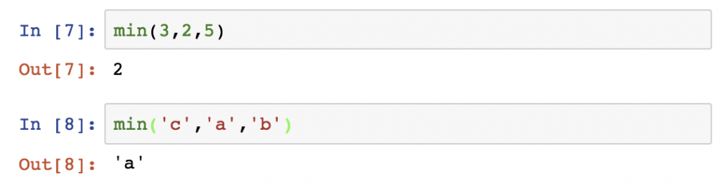

max()  
Guess, what! It’s the opposite of min().

sorted()  
It sorts a list into ascending order. The list can contain strings or numbers.  
Example:  
a = [3, 2, 1]  
sorted(a)

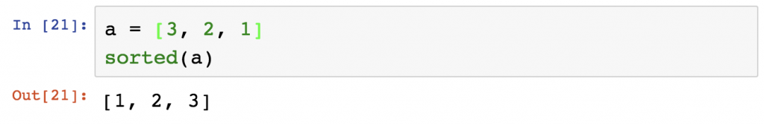

sum()  
It sums a list. The list can have all types of numeric values, although it handles floats… well, not smartly.  
Example1:  
a = [3, 2, 1]  
sum(a)  
Example1:  
b = [4/3, 2/3, 1/3, 1/3, 1/3]  
sum(b)

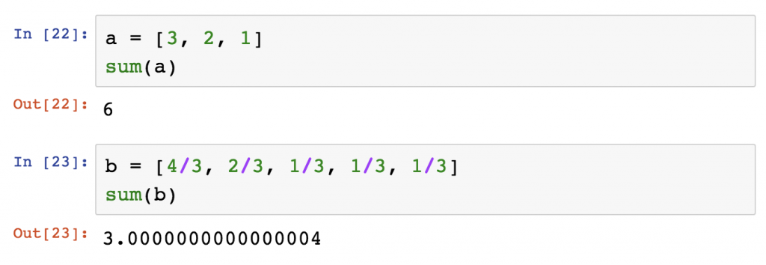

len()  
returns the number of elements in a list or the number of characters in a string.  
Example: len('Hello!')

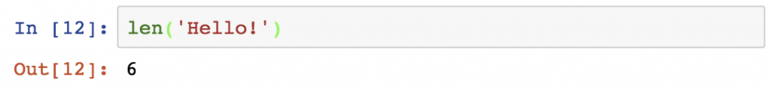

type()  
returns the type of the variable.  
Example 1:  
a = True  
type(a)  
Example 2:  
b = 2  
type(b)

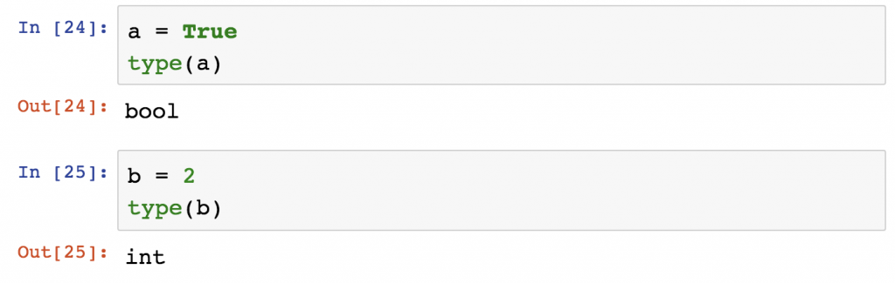

String Functions

a.lower()  
returns the lowercase version of a string.  
Example:  
a = 'MuG'  
a.lower()

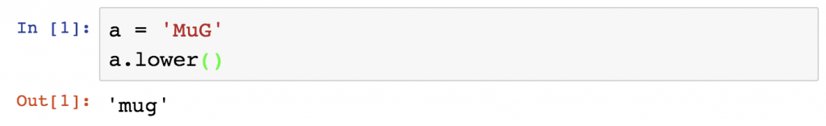

a.upper()  
the opposite of lower()

a.strip()  
if the string has whitespaces at the beginning or at the end, it removes them.  
Example:  
a = ' Mug '  
a.strip()

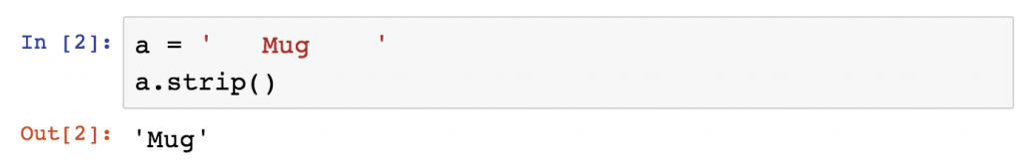

a.replace('old', 'new')  
replaces a given string with another string. Note that it’s case sensitive.  
Example:  
a = 'muh'  
a.replace('h','g')

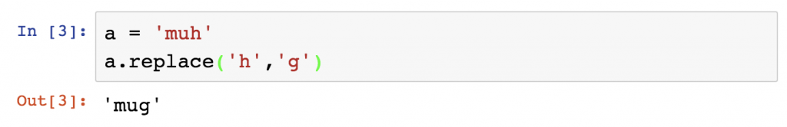

a.split('delimiter')  
splits your string into a list. Your argument specifies the delimiter.  
Example:  
a = 'Hello World'  
a.split(' ')  
*Note: in this case the space is the delimiter.*

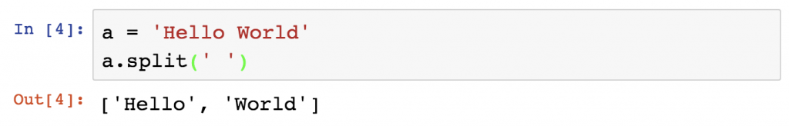

'delimiter'.join(a)  
It joins elements of a list into one string. You can specify the delimiter again.  
Example:  
a = ['Hello', 'World']  
' '.join(a)

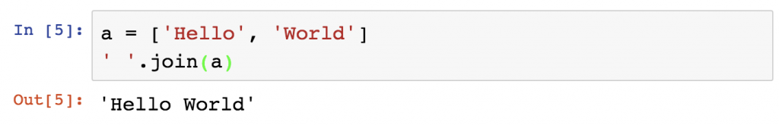

List Functions

Let’s bring back our favorite Python Dog, Freddie:  
dog = ['Freddie', 9, True, 1.1, 2001, ['bone', 'little ball']]

Let’s see how we can modify this list!  
a.append(arg)  
The .append() method adds an element to the end of our list. In this case, let’s say we want to add the number of legs Freddie has (which is 4).  
Example:  
dog.append(4)  
dog

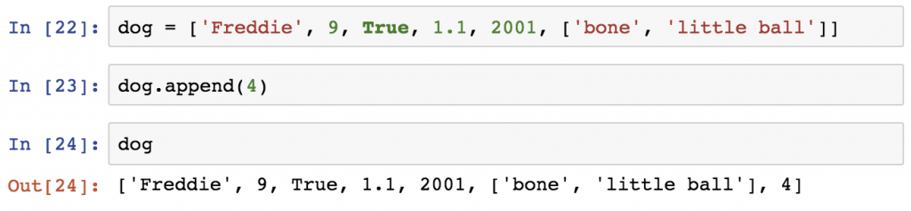

a.remove(arg)  
If we want to remove the birth year, we can do it using the .remove() method. We have to specify the element that we want to remove and Python will remove the first item with that value from the list.  
dog.remove(2001)  
dog

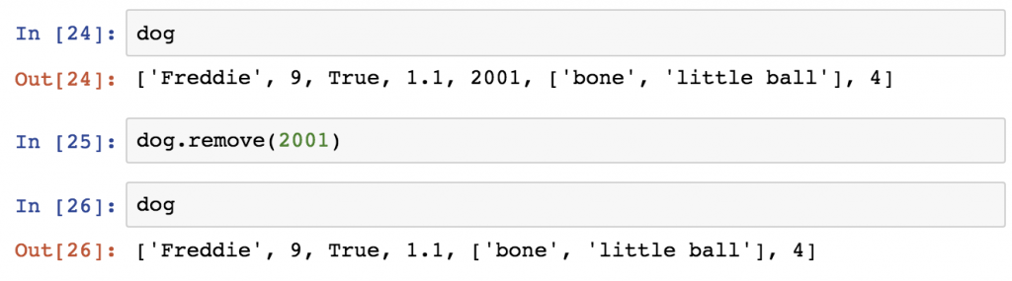

a.count(arg)  
returns the number of the specified value in a list.  
Example:  
dog.count('Freddie')

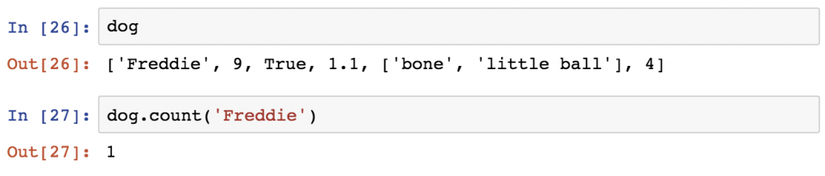

a.clear()  
removes all elements of the list. It will basically delete Freddie. No worries, we will get him back.  
Example:  
dog.clear()  
dog

